**Assignment 1 – Git**



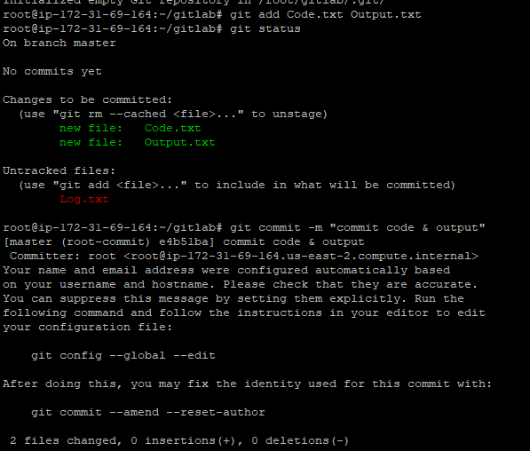

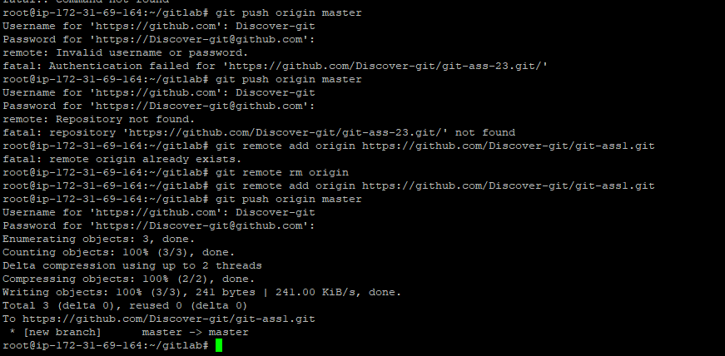

==================================================================================

**Assignment 2 – Git**

root@ip-172-31-69-164:~# mkdir git

root@ip-172-31-69-164:~# cd git

root@ip-172-31-69-164:~/git# touch feature1.txt feature2.txt

root@ip-172-31-69-164:~/git# git add . && git commit -m "commit master"

fatal: not a git repository (or any of the parent directories): .git

root@ip-172-31-69-164:~/git# git init

Initialized empty Git repository in /root/git/.git/

root@ip-172-31-69-164:~/git# git add . && git commit -m "commit master"

[master (root-commit) 3fcd293] commit master

Committer: root <root@ip-172-31-69-164.us-east-2.compute.internal>

Your name and email address were configured automatically based

on your username and hostname. Please check that they are accurate.

You can suppress this message by setting them explicitly. Run the

following command and follow the instructions in your editor to edit

your configuration file:

git config --global --edit

After doing this, you may fix the identity used for this commit with:

git commit --amend --reset-author

2 files changed, 0 insertions(+), 0 deletions(-)

create mode 100644 feature1.txt

create mode 100644 feature2.txt

root@ip-172-31-69-164:~/git# git checkout -b develop

Switched to a new branch 'develop'

root@ip-172-31-69-164:~/git# git checkout -b feature1

Switched to a new branch 'feature1'

root@ip-172-31-69-164:~/git# git checkout -b feature2

Switched to a new branch 'feature2'

root@ip-172-31-69-164:~/git# git checkout develop

Switched to branch 'develop'

root@ip-172-31-69-164:~/git# touch develop.txt

root@ip-172-31-69-164:~/git# git stash apply develop.txt

error: develop.txt is not a valid reference

root@ip-172-31-69-164:~/git# git stash apply

No stash entries found.

root@ip-172-31-69-164:~/git# git checkout feature1

Switched to branch 'feature1'

root@ip-172-31-69-164:~/git# touch new.txt

root@ip-172-31-69-164:~/git# git add new.txt && git commit -m "commit feature B"

[feature1 3b3c258] commit feature B

Committer: root <root@ip-172-31-69-164.us-east-2.compute.internal>

Your name and email address were configured automatically based

on your username and hostname. Please check that they are accurate.

You can suppress this message by setting them explicitly. Run the

following command and follow the instructions in your editor to edit

your configuration file:

git config --global --edit

After doing this, you may fix the identity used for this commit with:

git commit --amend --reset-author

1 file changed, 0 insertions(+), 0 deletions(-)

create mode 100644 new.txt

root@ip-172-31-69-164:~/git# git checkout develop

Switched to branch 'develop'

root@ip-172-31-69-164:~/git# git stash pop

No stash entries found.

root@ip-172-31-69-164:~/git# git add develop.txt && git commit -m "commit develop B"

[develop f1798d7] commit develop B

Committer: root <root@ip-172-31-69-164.us-east-2.compute.internal>

Your name and email address were configured automatically based

on your username and hostname. Please check that they are accurate.

You can suppress this message by setting them explicitly. Run the

following command and follow the instructions in your editor to edit

your configuration file:

git config --global --edit

After doing this, you may fix the identity used for this commit with:

git commit --amend --reset-author

1 file changed, 0 insertions(+), 0 deletions(-)

create mode 100644 develop.txt

root@ip-172-31-69-164:~/git# git checkout feature1

==========================================================================================

**Assignment 3 – Git**

root@ip-172-31-69-164:~# mkdir master

root@ip-172-31-69-164:~# cd master/

root@ip-172-31-69-164:~/master# touch main.txt

root@ip-172-31-69-164:~/master# git init

Initialized empty Git repository in /root/master/.git/

root@ip-172-31-69-164:~/master# git add . && git commit -m "commit master"

[master (root-commit) 3af01ca] commit master

Committer: root <root@ip-172-31-69-164.us-east-2.compute.internal>

Your name and email address were configured automatically based

on your username and hostname. Please check that they are accurate.

You can suppress this message by setting them explicitly. Run the

following command and follow the instructions in your editor to edit

your configuration file:

git config --global --edit

After doing this, you may fix the identity used for this commit with:

git commit --amend --reset-author

1 file changed, 0 insertions(+), 0 deletions(-)

create mode 100644 main.txt

root@ip-172-31-69-164:~/master# git checkout -b develop

Switched to a new branch 'develop'

root@ip-172-31-69-164:~/master# touch develop.txt

root@ip-172-31-69-164:~/master# git add develop.txt && git commit -m "commit develop"

[develop bb9e797] commit develop

Committer: root <root@ip-172-31-69-164.us-east-2.compute.internal>

Your name and email address were configured automatically based

on your username and hostname. Please check that they are accurate.

You can suppress this message by setting them explicitly. Run the

following command and follow the instructions in your editor to edit

your configuration file:

git config --global --edit

After doing this, you may fix the identity used for this commit with:

git commit --amend --reset-author

1 file changed, 0 insertions(+), 0 deletions(-)

create mode 100644 develop.txt

root@ip-172-31-69-164:~/master# git checkout -b f1

Switched to a new branch 'f1'

root@ip-172-31-69-164:~/master# touch f1.txt

root@ip-172-31-69-164:~/master# git add f1 && git commit -m "commit f1"

fatal: pathspec 'f1' did not match any files

root@ip-172-31-69-164:~/master# git add f1.txt && git commit -m "commit f1"

[f1 519b16c] commit f1

Committer: root <root@ip-172-31-69-164.us-east-2.compute.internal>

Your name and email address were configured automatically based

on your username and hostname. Please check that they are accurate.

You can suppress this message by setting them explicitly. Run the

following command and follow the instructions in your editor to edit

your configuration file:

git config --global --edit

After doing this, you may fix the identity used for this commit with:

git commit --amend --reset-author

1 file changed, 0 insertions(+), 0 deletions(-)

create mode 100644 f1.txt

root@ip-172-31-69-164:~/master# git chekout -b f2

git: 'chekout' is not a git command. See 'git --help'.

The most similar command is

checkout

root@ip-172-31-69-164:~/master# git checkout -b f2

Switched to a new branch 'f2'

root@ip-172-31-69-164:~/master# touch f2.txt

root@ip-172-31-69-164:~/master# git add f2.txt && git commit -m "commit f2"

[f2 cabfbf1] commit f2

Committer: root <root@ip-172-31-69-164.us-east-2.compute.internal>

Your name and email address were configured automatically based

on your username and hostname. Please check that they are accurate.

You can suppress this message by setting them explicitly. Run the

following command and follow the instructions in your editor to edit

your configuration file:

git config --global --edit

After doing this, you may fix the identity used for this commit with:

git commit --amend --reset-author

1 file changed, 0 insertions(+), 0 deletions(-)

create mode 100644 f2.txt

root@ip-172-31-69-164:~/master# git branch

develop

f1

* f2

master

root@ip-172-31-69-164:~/master# git remote add origin https://github.com/Discover-git/git-ass3.git

root@ip-172-31-69-164:~/master# git push origin --all

Username for 'https://github.com': Discover-git

Password for 'https://Discover-git@github.com':

Enumerating objects: 9, done.

Counting objects: 100% (9/9), done.

Delta compression using up to 2 threads

Compressing objects: 100% (7/7), done.

Writing objects: 100% (9/9), 780 bytes | 780.00 KiB/s, done.

Total 9 (delta 3), reused 0 (delta 0)

remote: Resolving deltas: 100% (3/3), done.

To https://github.com/Discover-git/git-ass3.git

* [new branch] develop -> develop

* [new branch] f1 -> f1

* [new branch] f2 -> f2

* [new branch] master -> master

root@ip-172-31-69-164:~/master# git checkout master

Switched to branch 'master'

root@ip-172-31-69-164:~/master# git branch -D f2

Deleted branch f2 (was cabfbf1).

root@ip-172-31-69-164:~/master# git branch

develop

f1

* master

root@ip-172-31-69-164:~/master# git push origin -d f2

Username for 'https://github.com': Discover-git

Password for 'https://Discover-git@github.com':

To https://github.com/Discover-git/git-ass3.git

- [deleted] f2

root@ip-172-31-69-164:~/master#

**Assignment 4 – Git**

root@ip-172-31-69-164:~# mkdir ga4

root@ip-172-31-69-164:~# cd ga4

root@ip-172-31-69-164:~/ga4# ls

root@ip-172-31-69-164:~/ga4# touch master.txt

root@ip-172-31-69-164:~/ga4# git init

Initialized empty Git repository in /root/ga4/.git/

root@ip-172-31-69-164:~/ga4# git add . && git commit -m "master commit"

[master (root-commit) 580fd0d] master commit

Committer: root <root@ip-172-31-69-164.us-east-2.compute.internal>

Your name and email address were configured automatically based

on your username and hostname. Please check that they are accurate.

You can suppress this message by setting them explicitly. Run the

following command and follow the instructions in your editor to edit

your configuration file:

git config --global --edit

After doing this, you may fix the identity used for this commit with:

git commit --amend --reset-author

1 file changed, 0 insertions(+), 0 deletions(-)

create mode 100644 master.txt

root@ip-172-31-69-164:~/ga4# git branch public1

root@ip-172-31-69-164:~/ga4# git branch public2

root@ip-172-31-69-164:~/ga4# git branch private

root@ip-172-31-69-164:~/ga4# git checkout public1

Switched to branch 'public1'

root@ip-172-31-69-164:~/ga4# touch public1.txt

root@ip-172-31-69-164:~/ga4# git add public1.txt && git commit -m "commit public"

[public1 403ff1c] commit public

Committer: root <root@ip-172-31-69-164.us-east-2.compute.internal>

Your name and email address were configured automatically based

on your username and hostname. Please check that they are accurate.

You can suppress this message by setting them explicitly. Run the

following command and follow the instructions in your editor to edit

your configuration file:

git config --global --edit

After doing this, you may fix the identity used for this commit with:

git commit --amend --reset-author

1 file changed, 0 insertions(+), 0 deletions(-)

create mode 100644 public1.txt

root@ip-172-31-69-164:~/ga4# git checkout master

Switched to branch 'master'

root@ip-172-31-69-164:~/ga4# git merge public1

Updating 580fd0d..403ff1c

Fast-forward

public1.txt | 0

1 file changed, 0 insertions(+), 0 deletions(-)

create mode 100644 public1.txt

root@ip-172-31-69-164:~/ga4# git merge public2

Already up to date.

root@ip-172-31-69-164:~/ga4# git checkout private

Switched to branch 'private'

root@ip-172-31-69-164:~/ga4# nano master.txt

root@ip-172-31-69-164:~/ga4# git add master.txt && git commit -m "commit private"

[private 671639d] commit private

Committer: root <root@ip-172-31-69-164.us-east-2.compute.internal>

Your name and email address were configured automatically based

on your username and hostname. Please check that they are accurate.

You can suppress this message by setting them explicitly. Run the

following command and follow the instructions in your editor to edit

your configuration file:

git config --global --edit

After doing this, you may fix the identity used for this commit with:

git commit --amend --reset-author

1 file changed, 1 insertion(+)

root@ip-172-31-69-164:~/ga4# git checkout public1

Switched to branch 'public1'

root@ip-172-31-69-164:~/ga4# git merge private

Merge made by the 'recursive' strategy.

master.txt | 1 +

1 file changed, 1 insertion(+)

root@ip-172-31-69-164:~/ga4# git checkout public2

Switched to branch 'public2'

root@ip-172-31-69-164:~/ga4# git merge private

Updating 580fd0d..671639d

Fast-forward

master.txt | 1 +

1 file changed, 1 insertion(+)

root@ip-172-31-69-164:~/ga4# git branch

* master

private

public1

public2

root@ip-172-31-69-164:~/ga4# touch new.txt

root@ip-172-31-69-164:~/ga4# git add . && git commit -m "commit mas"

[master bc45a46] commit mas

Committer: root <root@ip-172-31-69-164.us-east-2.compute.internal>

Your name and email address were configured automatically based

on your username and hostname. Please check that they are accurate.

You can suppress this message by setting them explicitly. Run the

following command and follow the instructions in your editor to edit

your configuration file:

git config --global --edit

After doing this, you may fix the identity used for this commit with:

git commit --amend --reset-author

1 file changed, 0 insertions(+), 0 deletions(-)

create mode 100644 new.txt

root@ip-172-31-69-164:~/ga4# git checkout private

Switched to branch 'private'

root@ip-172-31-69-164:~/ga4# git merge master

Updating 671639d..bc45a46

Fast-forward

new.txt | 0

public1.txt | 0

2 files changed, 0 insertions(+), 0 deletions(-)

create mode 100644 new.txt

create mode 100644 public1.txt

root@ip-172-31-69-164:~/ga4#

**Assignment 5 – Git**

197 mkdir git-workflow

198 cd git-workflow/

199 git init

200 git branch

201 git checkout -b develop

202 git checkout -b feature

203 git checout -b hotfix

204 git checkout -b hotfix

205 git checkout feature

206 git branch

207 git checkout -b feature

208 touch feature.txt

209 git add .

210 git commit -m "feature commit to fea"

211 git checkout develop

212 git checkout -b develop

213 git merge feature

214 git checkout master

215 git checkout -b master

216 git merge develop

217 git checkout -b hotfix-ungent

218 touch urgent.txt

219 git checkout master

220 git merge hotfix-ungent

221 git branch

222 ls

223 git push origin develop

224 git remote add origin https://github.com/GitHubvenkat1/5th-assignment.git

225 git push origin develop

226 git push origin master

227 cd ..

228 cd git-workflow/

229 git push origin -d master

230 git push origin -d develop

231 git branch -D develop

232 git push origin -d develop

233 cd ..

234 rm -r git-workflow

235 mkdir workflow

236 cd workflow/

237 touch test.txt && git add . && git commit -m "master commit"

238 git init

239 touch test.txt && git add . && git commit -m "master commit"

240 git branch develop

241 git branch feature

242 git branch hotfix

243 git checkout feature

244 touch feature.txt && git add . && git commit -m "feature commit #3"

245 git checkout develop

246 git merge feature

247 git checkout master

248 git merge develop

249 git checkout -b hotfix-urgent

250 touch urgent.txt

251 git checkout master

252 git merge hotfix-urgent

253 git remote add origin https://github.com/GitHubvenkat1/assign5.git

254 git push origin develop

255 git push origin master